MiSACWIS Project

RM03 – Create-Reopen Resource Home Record UCR
Version 1.0

September 20, 2011

Prepared for:


120 N. Washington Square
SACWIS Project, 3rd Floor
Lansing, MI 48933

Prepared by:

Revision Log
Version | Date | A/D/C (Add, Delete, Change) | Author | Document Section # | Description
0.1 | 09/07/2011 |  | Robert LaBarre |  | Initial version
1.0 | 09/20/2011 |  | Robert LaBarre |  | ART Completed
Table of Contents
1 Introduction 5
1.1 Purpose 5
1.2 Scope 5
2 Class Diagram 6
3 Sequence Diagram 7
4 Business Data Dictionary 8
4.1 CRUD Matrix 8

List of Figures
Figure 1 – Class Diagram 6
Figure 2 – Sequence Diagram 7

Introduction

Purpose
This document describes the process for creating or linking a Provider Home record.

Scope
This document describes the technical design for the RM03 – Create/Reopen Provider Home Record use case based on the screen specs created for the same use case.

Class Diagram
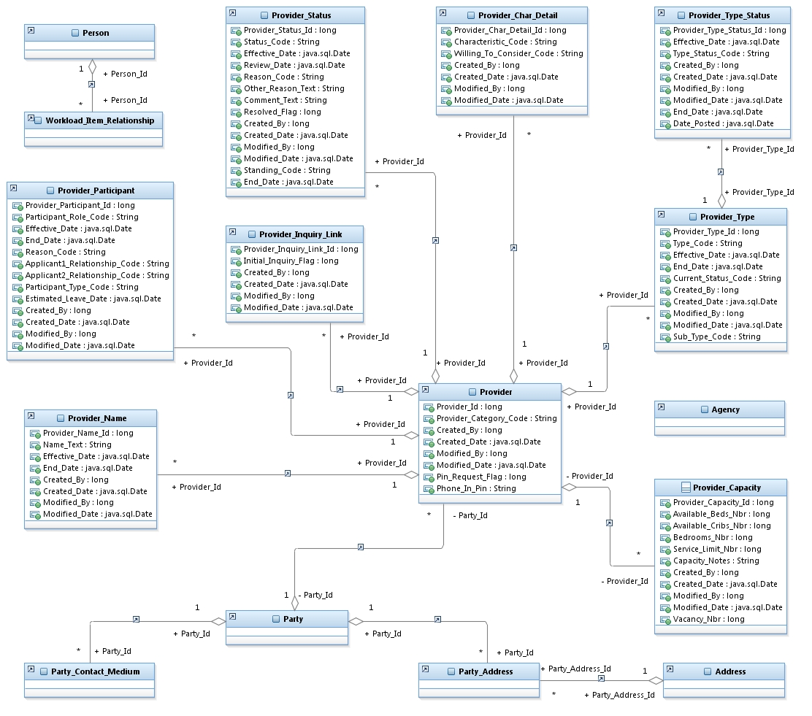
Figure 1 – Class Diagram

Sequence Diagram

Figure 2 – Sequence Diagram

Business Data Dictionary

CRUD Matrix
Class | Create | Read | Update | Delete
Provider | X | X | X
ProviderParticipant | X | X | X
ProviderType | X | X | X
ProviderTypeStatus | X | X | X
ProviderStatus | X | X | X
ProviderName | X | X | X
ProviderInquiryLink | X | X
ProviderCapacity | X
ProviderCharDetail | X | X | X
Party | X | X
PartyContactMedium | X | X
PartyAddress | X | X
Agency |  | X
Person |  | X
Address |  | X
WorkloadItemRelationship |  | X

